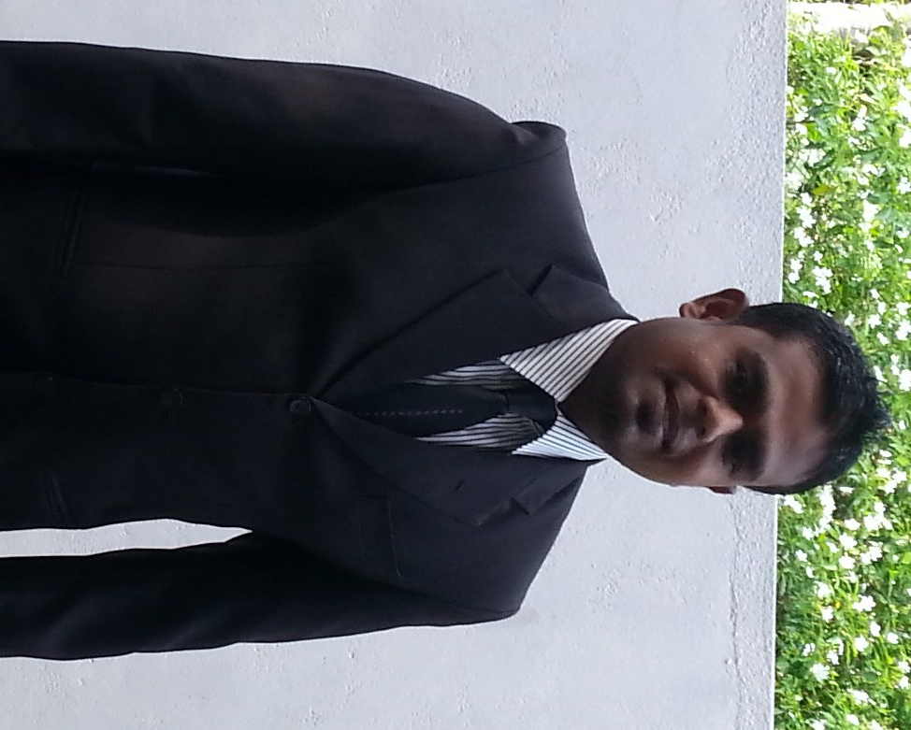
Marappulige Praboda Lalanda
No. 68/1B, Henagedara Road, Maharagama
Mobile: +94 - 768419324 / +94 (011) – 2841906
E-mail: praboda.lalanda@gmail.com

Summary & Objective

9 years experienced in Ship Chandelling and Sales & Marketing Executive. Have the experience on working with less supervision and under pressure in UAE and QATAR. Ability to integrate with all Nationalities and to get the best from staff and colleagues alike. A positive thinker with can do attitude. Also, eager to acquire knowledge and experience from the leading business organization by securing a position with talent demanding tasks.

Personal Information
- Date of Birth : 10 November 1981
- Gender : Male
- Marital Status : Married
- School : Mahanama Collage, Colombo-03, Sri Lanka

Work History
Seven Sea Ship Chandlers in Doha, Qatar.
- Since 2012 to 2014 : Sales Executive & Purchasing Officer
    - Since 2010 to 2012 : Stores in charge
    - Since 2006 to 2010 : Boarding Representative

PAN Arabian Ship Chandlers ,U.A.E
- Since 2004 to 2005 : Boarding Representative
- Since 2003 to 2004 : Store Keeper

H&H Fashion Garment
- Since 2001 to 2003 : Production Supervisor

Professional Qualifications
- Accomplished Management Course of Garment Trade.
- Customs training course for Custom House Agents and Wharf Assistant at human resource directorate of Sri Lanka.
- Full time intensive course in English speech, grammar and elocution at IEM
- Safety Food Handling Training Course in Qatar
Academic Background
- 1998 – 2000: GCE Advance Level
Mahanama Collage, Colombo-03, Sri Lanka

- 1988 – 1997: G.C.E Ordinary Level
Mahanama Collage, Colombo-03, Sri Lanka

Curricular Activities
- Played in school cricket & rugby teams (under 13 to 19)
- Played in several domestic cricket Clubs.
- Other Achievements
  - Become a best baller in school big match
  - Won several other challenges during the school days.

Core Competencies
- Holding a Valid Driving License in UAE and QATAR.
- Strong English communication skills – written, spoken, & presentations
- Ability to converse in Hindi
- Highly proficient in Microsoft Office packages
- Leadership skills - organizing, team-working
- Ability to manage multiple commercial processes
- Ability to priorities workload; work effectively under pressure and tight deadlines.
- Time management skills

References

Mr. Sibu Kunjukutty Mr. Santhush Premawardena
Team Leader Shipping Executive
Sevenseas Shipchandlers Kanoo Shipping
Mobile: +97455861546 Mobile: +971553698070

I hereby certify that above details are true and accurate to the best of my knowledge.

………………..... ……………
Praboda Lalanda Date

